Loan Menu

The user will be presented with the menu illustrated below if they select “LOAN” from the “Main Menu”.

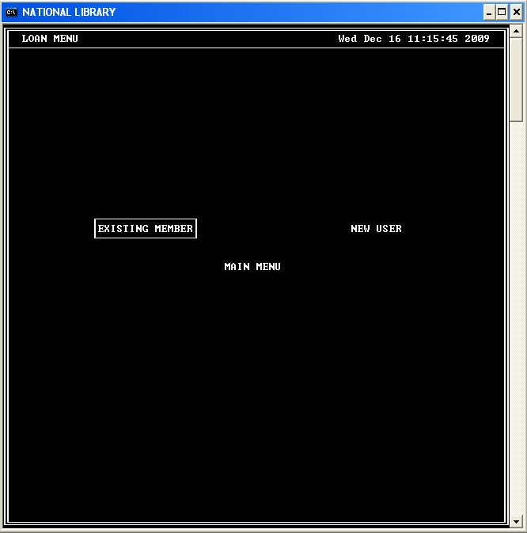

You must have a valid user ID in order to create a loan so the user should select “NEW USER” from this menu to register a new user if one has now already been created.

If the user chooses to register a new user, the form below will be presented to them.

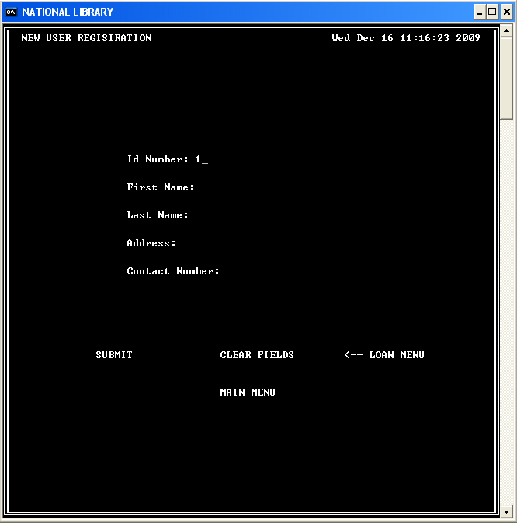

The value for the ID Number field is automatically generated for the user.

I the user complete the form, as shown in the example below.

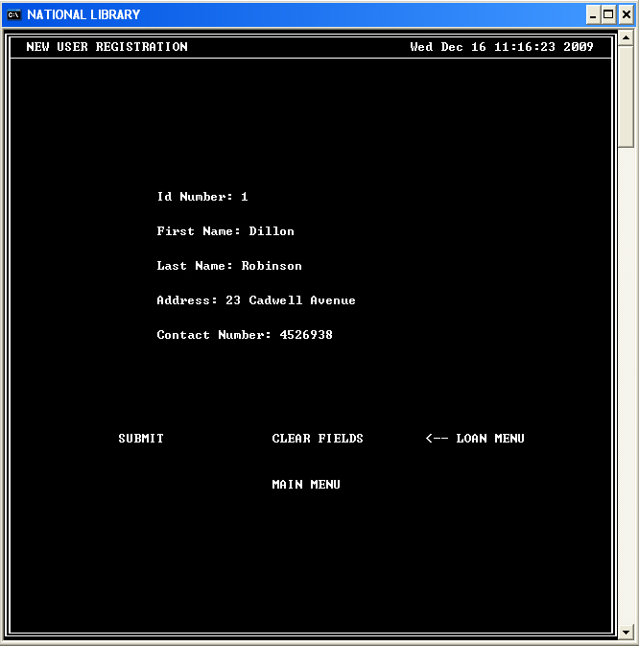

They will be able to select one of the options below the form.

If they choose to submit the data, they will be presented with an option to confirm their action or to cancel.

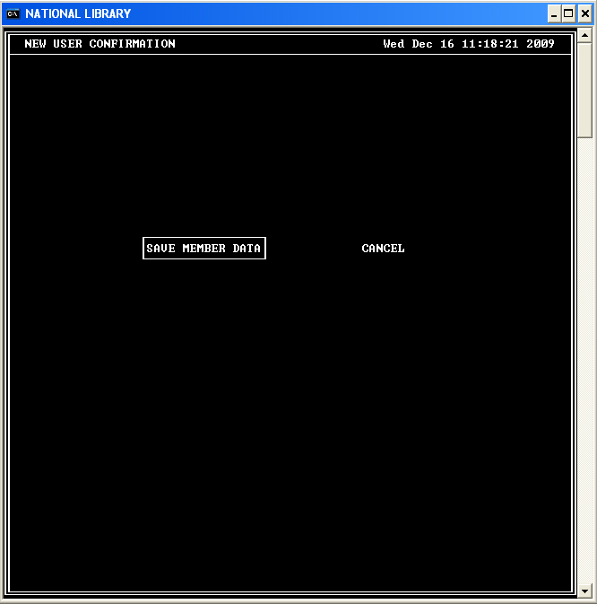

By selecting “SAVE MEMBER DATE”, the data entered will be saved and displayed to the user as illustrated below.

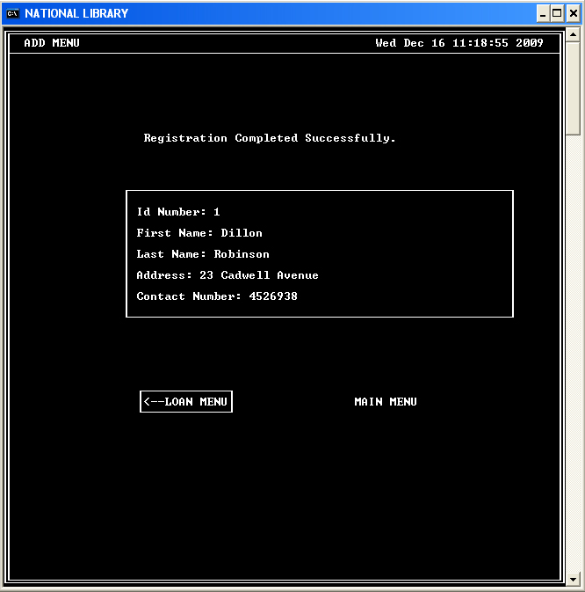

The user can then return to the “Loan Menu” or to the “Main Menu”.

Upon returning to the “Loan Menu”, the user will once again be presented with the option of registering new user or to loan a reference material to an existing user by selecting “EXISTING MEMBER” from the menu show below.

After selecting to loan to an existing member, the user will be presented with the following form.

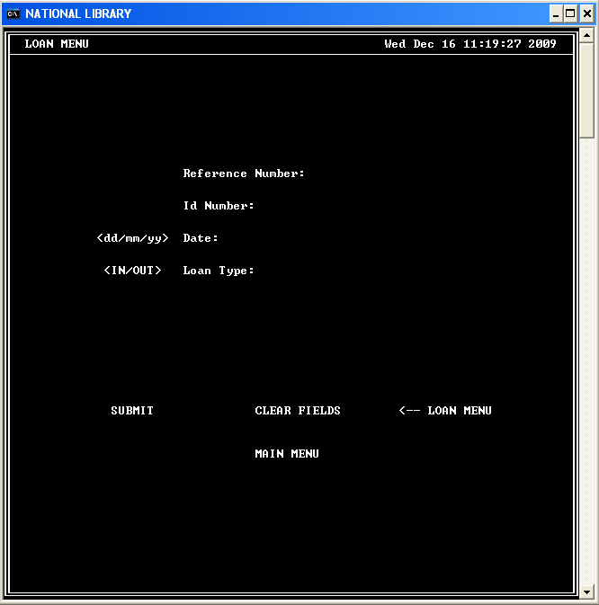

Upon completing the form:

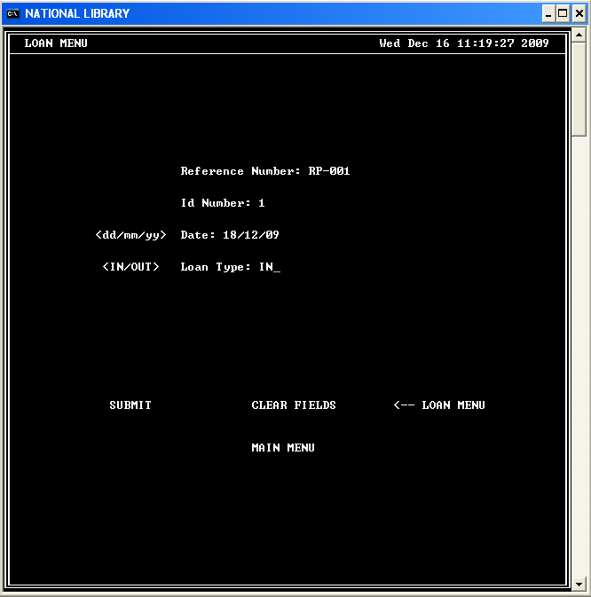

The confirmation menu will be shown to the user.

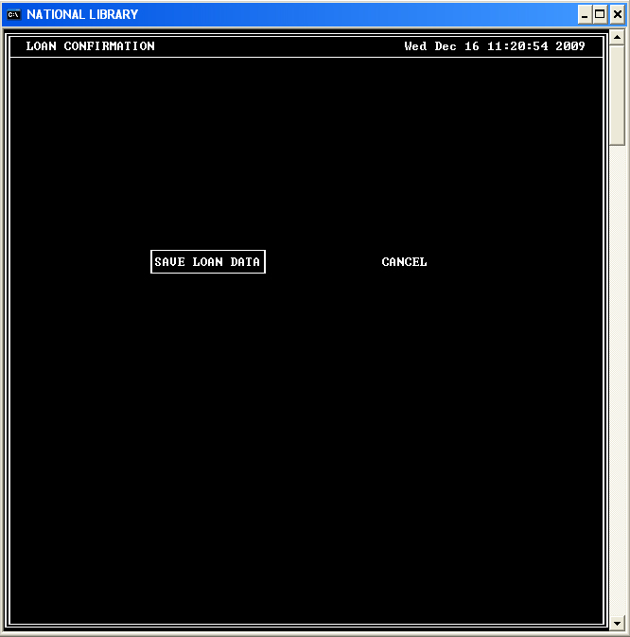

By confirming to save the loan data, the data will be saved and displayed to the user.

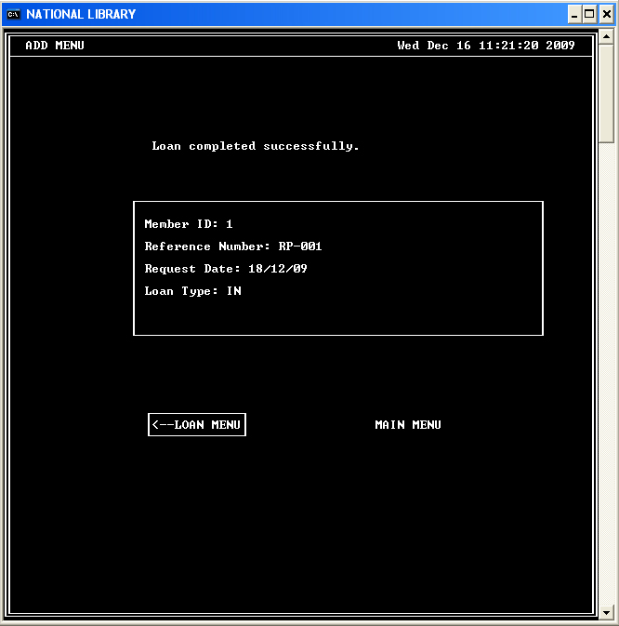

The user can then choose to return to the loan menu or to return to the main menu.

